A Snake in the Garden of Eden

SEHDEV KUMAR

PUBLISHED AUGUST 7, 2000

Globe & Mail, CANADA

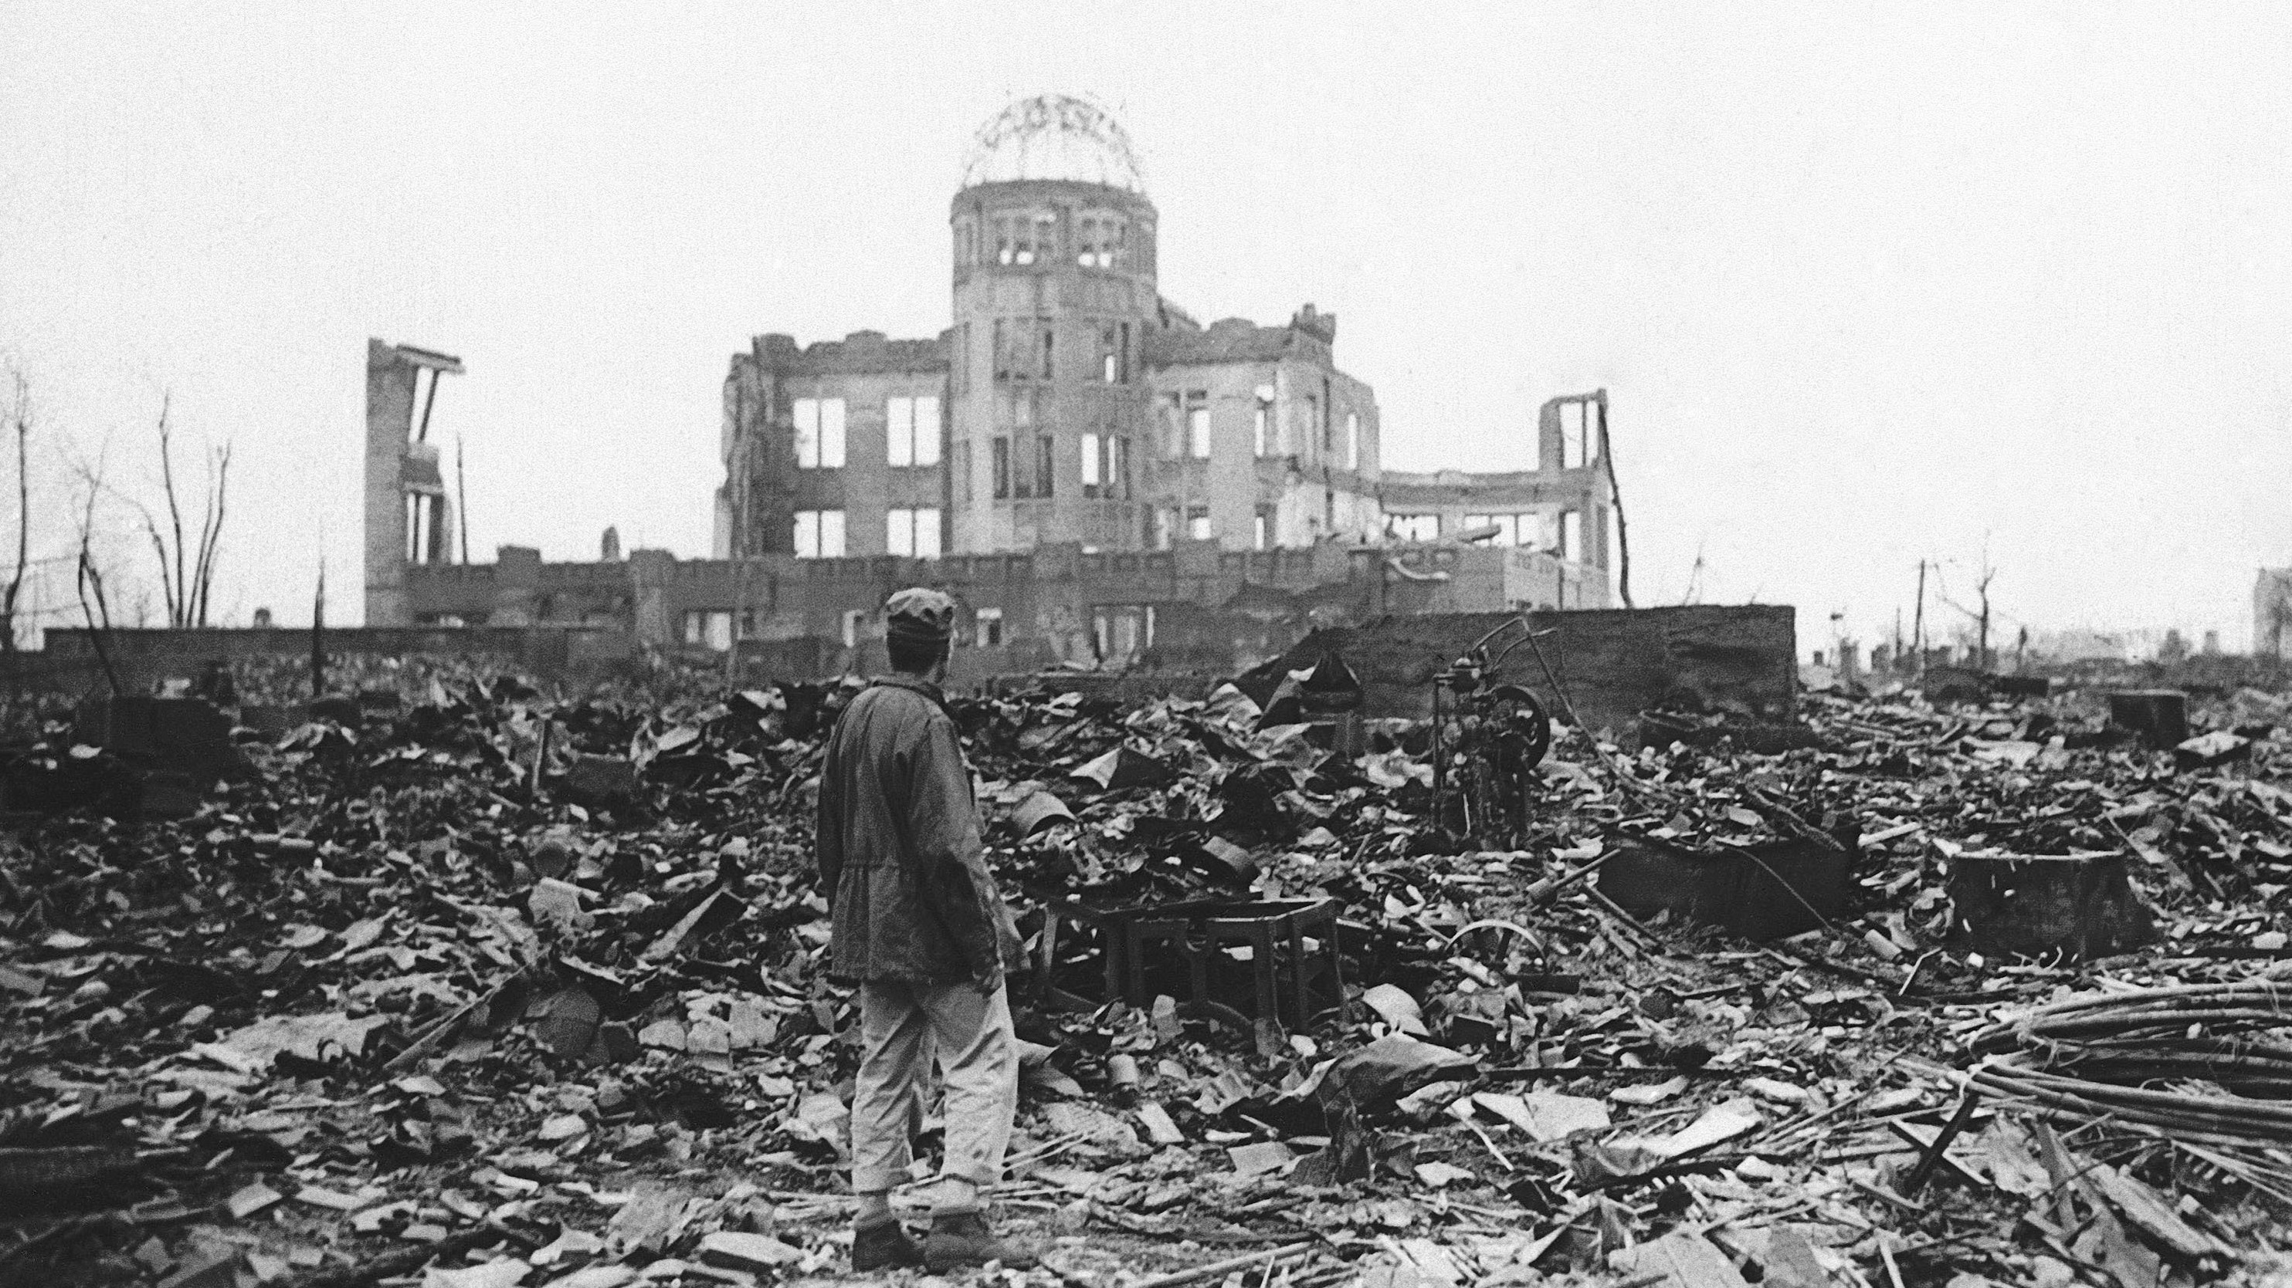

War correspondents toured the destruction a month after the blast and found little remained of the centre of Hiroshima. The ruins of what was once a movie theatre were later preserved as a memorial.

M

r. President, I feel I have blood on my hands," said Robert J. Oppenheimer, the father of atom bomb, to Harry Truman in November, 1945. The President contemptuously offered Oppenheimer a handkerchief and said: "Well, here, would you like to wipe off your hands?"

After he left the Oval Office, Truman turned to Dean Acheson, Undersecretary of State, and said: "I don't want to see that son of a bitch in this office ever again."

Such were the passions that marked the Manhattan Project -- the story of the making of the A-bomb in 1940s in Los Alamos in New Mexico under the direction of physicist Oppenheimer and General Leslie Groves. This most awesome and grand collective undertaking to create the Ultimate Weapon is a rivetting drama that has made all of us, and all succeeding generations, willing or unwilling actors in a monstrous and tragic tale. And it seems to know no end.

The fierce and utterly unknown genie of nuclear power was first released 55 years ago on Point Zero in a desert in New Mexico in a test, blasphemously named The Trinity. With all their ingenious calculations, no one had quite guessed the immensity of power that was released in the explosion. Transfixed with fright, as the scientists and the others watched the desert lit "by a searing light with an intensity many times that of the midday sun," a passage from the Bhagavad Gita, the sacred epic of the Hindus, flashed into Oppenheimer's mind: “

*If the radiance of a thousand suns were to burst into the sky, that would be like the splendour of the Mighty One.*

Yet, when the sinister and gigantic cloud rose in the far distance, he was reminded of another line from the same epic:

*I am become Death, the shatterer of worlds.*

In the epic, the words are of Sri Krishna, the Exalted One, Lord of the fate of the mortals. On the tongue of humans, however, the words became menacingly foreboding. Man was now in possession of a mighty new instrument of darkness.

A mere three weeks later, on Aug. 6, 1945, the first bomb was dropped over Hiroshima, and then another on Nagasaki, heralding the end of a long and gruesome war, but also the beginning of a deadly nuclear-arms race.

The scientists - Oppenheimer foremost among them - were hailed as titans and compared with Prometheus, who had challenged Zeus, the controller of Fates. But as the horrors of radiation deaths started pouring in from Japan, some began to call the scientists Devil Gods. Oppenheimer himself, even as he basked in the public glory and adulation, began to confess ruefully that "we did devil's work."

This moral ambivalence earned Oppenheimer the nickname "the crybaby scientist" from Truman, and cost him dearly. In 1954, a three-man Board of the Atomic Energy Commission of the United States stripped him of his security clearance. The "devil's work" that Oppenheimer believed scientists had been engaged in had now moved securely into the hands of the father of the H-Bomb, Edward Teller, who considered nuclear arms synonymous with progress. "To abstain from progress is a Medieval idea," he argued. "I am in favour of any advance in knowledge or any development of the greater power of man." He went on to propose and plan the "Star Wars" defence initiative for President Reagan in 1980s.

The pursuit of truth through science has long been a noble and exalting activity. "Deny the powerful and their warriors entry to your workshops," warned the alchemists - the precursors of modern science. Greek geometrician Euclid, when asked by someone what was the practical use of his ideas, is reported to have told his slave sardonically: "He wants to profit from learning - give him a penny." Pythagoras, the founder of Greek mathematics in 6th century B.C., offered a hundred oxen to the Muses in thanks for the inspiration for his great theorem named after him. To his followers, he was a magician and a mystical seer who saw harmony everywhere, in nature and in music, which could be expressed in numbers. And other greats in science - Newton, Darwin, Kepler, Mendeleev, Marie Curie, Einstein - have all created an aristocracy of intellect before which any other group pales in comparison. Wars and dictators come and go, said Einstein, but "a mathematical equation stands forever."

There is a story told about the pioneering physicist Ernest Rutherford at Cambridge towards the end of the First World War. He once failed to attend a meeting of the British committee of experts appointed to advise on new systems of defence against enemy submarines. When he was censured for his absence, he retorted without embarrassment: "Talk softly, please. I have been engaged in experiments that suggest that the atom can be artificially disintegrated. If it is true, it is of far greater importance than a war."

Such stories about the pure and exalted pursuit of science have made the scientist, over centuries, a symbol not only of penetrating intellect and detached reasoning but of highest human integrity itself. It is thus that scientific academies of the 17th century decided that any discussion of political, religious or moral problems would not be permitted in their meetings, lest their pursuit of scientific truth be marred by dogma or human passions.

In 1945, in one swoop, all that changed. With Hiroshima, a snake had entered the Garden of Eden of science.

"The lure of the technically sweet," as Oppenheimer described it, and the entrapments of power and money began to rob the scientists of their innocence. "It is my judgment in these things," he said, "that when you see something that is technically sweet you go ahead and do it and you argue about what to do about it only after you have had your technical success. That is the way it was with the atomic bomb."

There is a story told about a young scientist in Los Alamos, where walking down the street one evening, he was observed to be bearing a smile of almost angelic beauty. He looked as though his inner gaze was fixed on a world of harmonies. He was, in fact, he said later, thinking about a new mathematical problem whose solution was essential to the construction of a new kind of hydrogen bomb.

For this scientist, as for many others, research in nuclear weapons was yet another problem in pure mathematics, unsullied by blood, cries or destruction. All that, he is reported to have said, was none of his business. He had even refused to watch trial explosions of any of the bombs that he had helped design. Nor did he wish to visit the cities of Hiroshima and Nagasaki, though he was invited; or even look at the pictures of destruction wrought by the two bombs.

During the War, many scientists believed, as did Albert Einstein, that it was necessary to build the atomic bomb before the Germans did. But Sir Mark Oliphant, an Australian physicist who worked on the project, added a new note many years later: "I learned during the war that if you pay people well and the work's exciting they'll work on anything. There's no difficulty getting doctors to work on biological warfare, chemists to work on chemical warfare and physicists to work on nuclear warfare."

The observations are chilly and disconcerting. Hiroshima did, nevertheless, prompt a vigorous movement among scientists against nuclear arms. The scientists' movement for world government and international control of atomic energy was sustained by a prevailing belief that commitment to science almost automatically gave one a global perspective and a unique ethical vintage point. For many, as distinguished physicist James Frank put it, scientists were members of a "kind of international brotherhood, comparable in many ways to religious order," whose public activities were "dictated solely by our social conscience."

In an article in the Scientific American, Hans Bethe, a prominent atomic scientist in the Manhattan Project, asked: "Shall we convince the Russians of the value of the individual by killing millions of them? If we fight a war and win it with H-bomb, what history would remember is not the ideals we were fighting for but the methods we used to accomplish them. These methods will be compared to the warfare of Genghis Khan, who ruthlessly killed every last inhabitant of Persia."

Thousands of copies of this issue of Scientific American were confiscated and burned by FBI.

I studied physics in India and later at the University of Toronto. At a recent reunion of some of our physicist friends, I wondered aloud, with some amusement and disquiet, that if I had continued in physics, perhaps I too would have been enrolled in India's nuclear program, and possibly contributed to the A-bomb tested two years ago, in May 1998. And then I, too, in all likelihood, would have rejoiced in its triumphant chauvinism.

Questions of ethics - of right and wrong - are not only embedded in the individual conscience; there is a certain social dynamic, which in a state of fear or war, has its own passionate sway on individual hearts and minds.

Despite all the human foibles and corporate temptations of grants and patents - what is called "intellectual property" - that are now an integral part of the pursuit and practice of science, can one still believe in the nobility of the pursuit of truth, unsullied by human passions? I dare hold that the "lure of the technically sweet" must somehow give way to the sweetness of life itself, in all its luxuriant fecundity. That's an ethics and an oath by which all of us - and the scientists foremost among us - must choose to learn to live, thus truly "touching upon Hope," as Francis Bacon, a much-maligned philosopher of science, asserted 400 years ago.

Science prides itself in its unflinching commitment to dispassionate reason. Yet reason can't be enough. Because of its immense power, science must learn to choose between what is right and what is wrong. Science knows how to do many things, but it does not always know what to do, or why. It is thus we experience world-wide ecological crisis and intractable problems in bioethics on one hand, and simmering plague of depression and inward disgrace on another.

No other life form on this planet is endowed with this special gift of reason and choice. We alone, among the multitudinous diversity of life, have this unique capacity to place ourselves in an ever-growing circle of compassion. Science has increasingly brought us within the laws of nature and has made our world natural. There is no retreat from this magnificent achievement.

Still, human freedom, tangled though it is in the passions of our own making, has left us the difficult choice of determining what it is in our nature to be: To remain God's glorious creatures or to make ourselves gods. Perhaps that is the meaning of the ancient story of the Garden and the Fall.

In scientific circles, there is a story told about one of the chief architects of the atomic bomb. On a walk in the woods with a friend once, he saw a tiny tortoise and picked it up, hoping to amuse his children with it. He had, however, not gone very far when he decided to turn back. Carefully he retraced his steps and put the small creature in its place to let it wander on its way again. Then he turned solemnly to his friend. "It struck me," he said, "that perhaps, for one man, I have tampered enough with the universe."

It was a small gesture in a vast universe, but it was the wisest recognition by a man of science that science alone is not enough for man and that the way back to the Garden is through the heart and splendours of life itself.

Dr. Sehdev Kumar is Professor Emeritus of Environmental Studies at the University of Waterloo. Author of **Vision of Kabir**, he is a winner of the Templeton course prize on Science-Religion dialogue, about which he comments regularly.

E-Mail: [kumarsehdev455@gmail.com](mailto:kumarsehdev455@gmail.com)